Generative AI(AD23633)

Project Title:

Mental health chatbot using LLM

Submitted by:

GUGAN M
231801046
AIDS

MENTAL HEALTH CHATBOT USING LLM

ABSTRACT
Mental health support is essential in today’s fast-paced world, yet many individuals struggle to seek help due to stigma, lack of awareness, or limited access to professional resources. Traditional counseling methods, although effective, are often time-consuming, costly, and not always available for immediate assistance.
This project presents an AI-powered mental health chatbot enhanced with a Large Language Model (LLM) that provides real-time emotional support and guidance. Unlike traditional systems that rely solely on predefined responses or basic Machine Learning techniques, this chatbot leverages LLM capabilities to generate context-aware, human-like, and empathetic responses.
The system understands user emotions such as stress, anxiety, and sadness through natural conversation and responds dynamically. It offers personalized coping strategies, relaxation techniques, and motivational guidance tailored to individual needs. Additionally, conversational memory enables continuity, making interactions more engaging and meaningful.
By combining structured intent detection with LLM-based response generation, the chatbot ensures both reliability and flexibility, improving the overall effectiveness of digital mental health support systems.

INTRODUCTION
Mental health and emotional well-being are critical components of a person’s overall quality of life. However, many individuals face difficulties in expressing their emotions or accessing support due to social stigma, lack of awareness, or limited availability of professionals.
With increasing academic pressure, lifestyle challenges, and social isolation, issues such as stress, anxiety, and depression are becoming more prevalent. While traditional counseling provides valuable support, it may not always be accessible due to cost, time constraints, or hesitation to seek help.

Advancements in Artificial Intelligence and Natural Language Processing (NLP) have enabled the development of intelligent conversational systems. Among these, Large Language Models (LLMs) have revolutionized chatbot capabilities by enabling:
Deep understanding of natural language
Context-aware conversations
Human-like response generation
This project focuses on developing a mental health chatbot powered by an LLM, capable of understanding user emotions and providing empathetic, meaningful, and personalized responses. The chatbot acts as a virtual companion, offering immediate and continuous support in a safe and private environment.

PROBLEM STATEMENT
Many individuals lack immediate access to mental health support and often suppress their emotions due to stigma or fear of judgment. Existing chatbot systems are limited because:
They rely on predefined responses
They lack deep emotional understanding
They cannot handle complex or dynamic conversations
There is a need for an intelligent system that:
Understands natural language in depth
Identifies emotional states accurately
Generates dynamic and empathetic responses
Provides personalized mental wellness guidance
Maintains conversational context

OBJECTIVES
To develop a mental health chatbot using a Large Language Model
To understand and analyze user emotions through natural conversation
To provide empathetic, human-like responses
To suggest coping strategies and mental wellness practices
To maintain conversational memory for continuity
To combine LLM capabilities with structured intent detection for reliability
To create an accessible, private, and real-time support system

LITERATURE SURVEY
Earlier mental health chatbots primarily used rule-based systems or Machine Learning models such as Bag of Words and intent classification. While these approaches improved response speed and structure, they lacked flexibility and struggled with complex emotional expressions.
Recent advancements in Large Language Models (LLMs) have significantly improved chatbot performance. LLMs are capable of:
Understanding context and nuances in conversation
Generating natural, human-like responses
Adapting to different user inputs dynamically
However, purely LLM-based systems may sometimes produce inconsistent or uncontrolled responses. Therefore, combining:
Intent classification (for control)
LLM response generation (for flexibility)
Creates a more balanced and effective solution. This project adopts this hybrid approach.

SYSTEM ARCHITECTURE

User Input
↓
Preprocessing (Tokenization & Cleaning)
↓
Intent Detection (Optional ML Layer)
↓
Context Handling (Conversation Memory)
↓
LLM Processing (Understanding + Response Generation)
↓
Response Filtering & Safety Check
↓
Chatbot Output

METHODOLOGY
- Data Collection
Mental health conversational datasets
Emotional expression patterns
Intent categories (stress, anxiety, motivation, etc.)
- Preprocessing
Lowercasing text
Removing noise and special characters
Tokenization
- Intent Detection (Optional Layer)
Classifies user input into categories
Helps guide structured responses when needed
- LLM Integration
User input is passed to the LLM
Model generates context-aware and empathetic responses
- Conversational Memory
Stores previous interactions
Maintains context across conversations
- Response Generation
LLM produces dynamic responses
Combined with predefined safety and support guidelines
- Safety & Filtering
Ensures responses are appropriate and supportive
Prevents harmful or misleading outputs

TECHNOLOGIES USED
Python
Transformer-based LLM (e.g., GPT-like models)
NLP libraries (NLTK / spaCy)
TensorFlow / PyTorch (optional)
HTML, CSS, JavaScript (Frontend)
DATASET DESCRIPTION
The dataset includes conversational data for training and supporting chatbot responses.
Fields:
User input (text)
Intent category
Emotional label
Sample responses
Example:
Input: “I feel anxious about exams”
Tag: Anxiety
Response: “It’s completely normal to feel this way. Try breaking your study plan into small steps.”

IMPLEMENTATION
Modules
- Input Module
Accepts user messages through UI
- NLP Module
Processes and cleans input text
- LLM Module
Generates responses using contextual understanding
- Memory Module
Maintains conversation history
- Safety Module
Filters inappropriate outputs
- Frontend
Chat interface for user interaction

Code:
From openai import OpenAI

Client = OpenAI(api_key=”YOUR_API_KEY”)

Def get_response(user_input):
Response = client.chat.completions.create(
Model=”gpt-4o-mini”,
Messages=[
{“role”: “system”, “content”: “You are a supportive mental health assistant.”},
{“role”: “user”, “content”: user_input}
]
)
Return response.choices[0].message.content

While True:
User_input = input(“You: “)
If user_input.lower() == “exit”:
Break
Reply = get_response(user_input)
Print(“Bot:”, reply)
Frontend:
<!DOCTYPE html>
<html>
<head>
<title>Mental Health Chatbot</title>
</head>
<body>

<div id=”chatbox”></div>
<input id=”userInput” placeholder=”Type here...” />
<button onclick=”sendMessage()”>Send</button>

<script>
Function sendMessage() {
Let input = document.getElementById(“userInput”).value;

Let chatbox = document.getElementById(“chatbox”);
Chatbox.innerHTML += “<p><b>You:</b> “ + input + “</p>”;

// Dummy response (replace with backend call)
Chatbox.innerHTML += “<p><b>Bot:</b> I’m here for you. Tell me more.</p>”;
}
</script>

</body>
</html>

Screen shot:
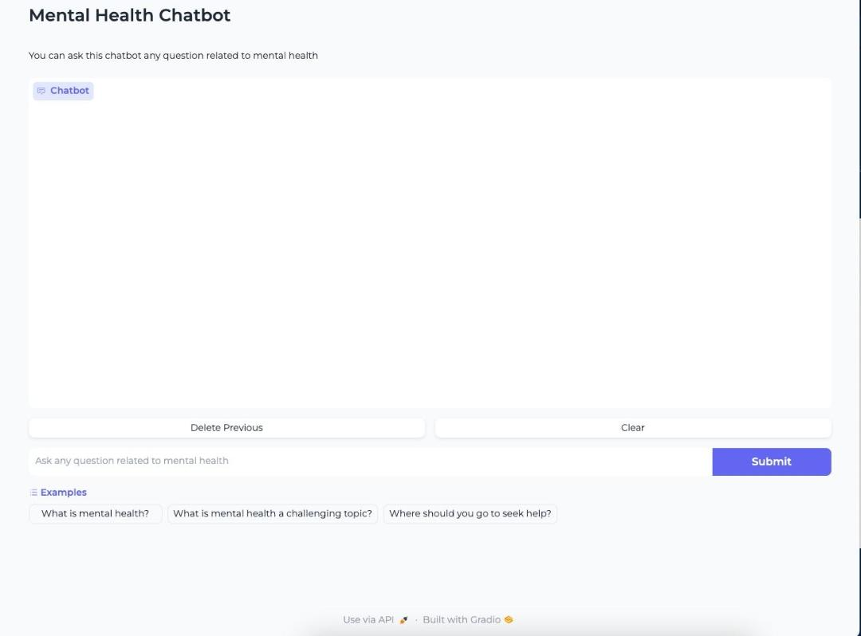

CONCLUSION
The proposed system demonstrates how Large Language Models can significantly enhance mental health chatbots by providing empathetic, context-aware, and dynamic responses. Unlike traditional systems, this approach improves user engagement and emotional understanding.
The chatbot serves as a supportive virtual companion, offering immediate assistance and promoting mental well-being in a private and accessible manner.
FUTURE ENHANCEMENTS
Integration with voice-based interaction
Emotion detection using speech and facial analysis
Personalized mental health tracking
Integration with professional counseling services
Multilingual support

